Name: Atharva Dharmendra Jagtap Rollno. 10937 Dept: CSE Year: SE
Total Covered:
- Arrays – 9
- Queue – 3
- Stack – 4
- Linked List – 3
- Graph – 3
- Tree – 3
- Hash Table – 3

Topics Covered: Linked List / Graph / Heap / Queue
Level: Hard
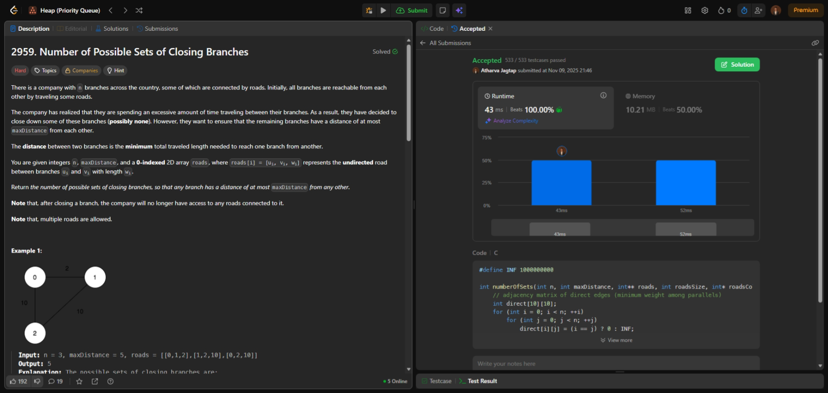

Topics Covered: Array / Queue / Heap
Level: Hard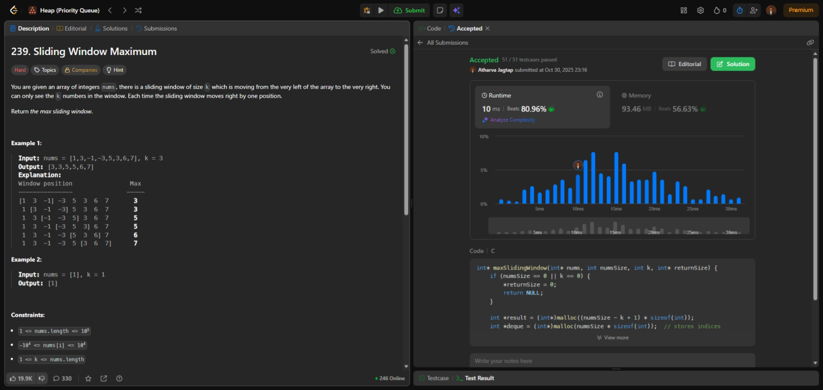

Topics Covered: Array / Hash Table
Level: Hard

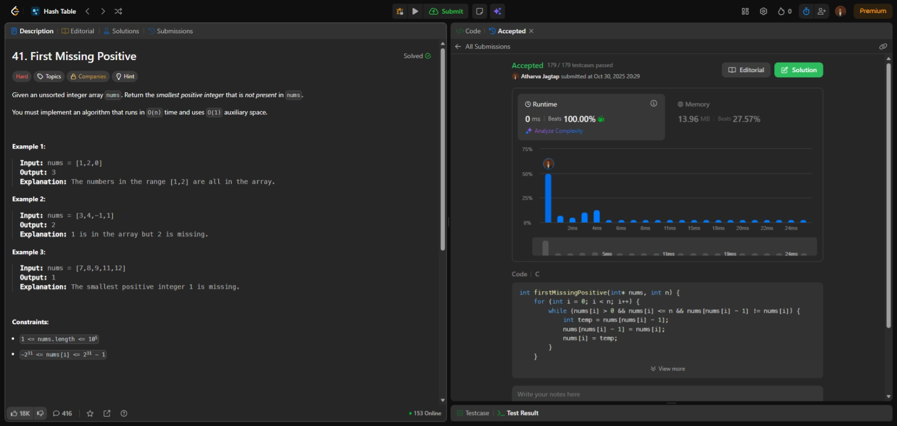

Topics Covered: Array / Hash Table
Level: Medium

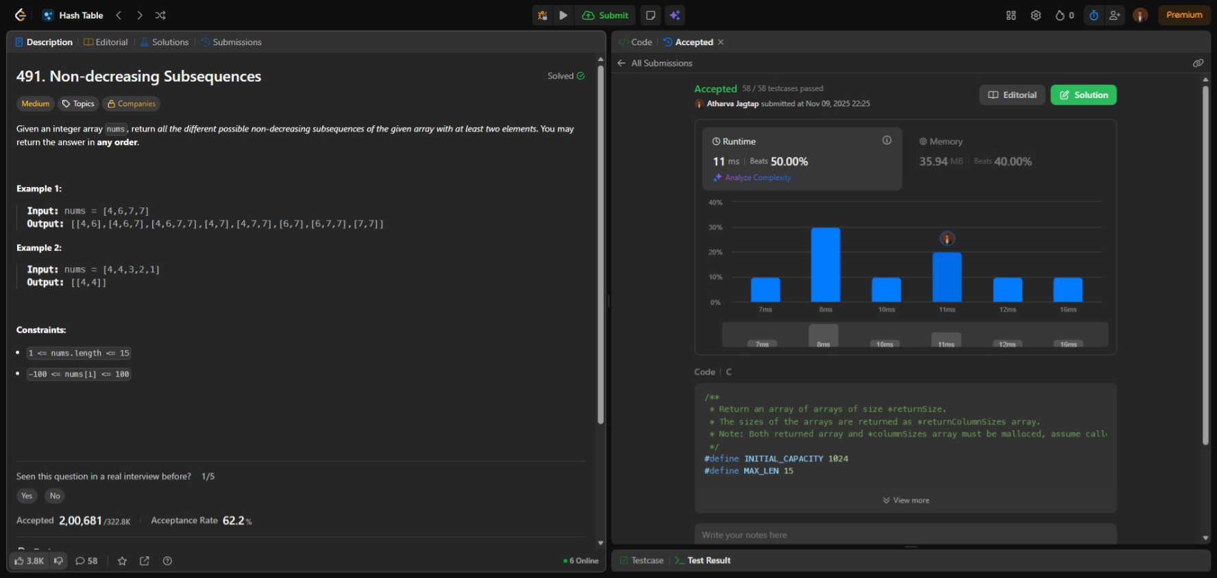

Topics Covered: Linked List / Tree / Binary Tree / DFS / Stack
Level: Hard

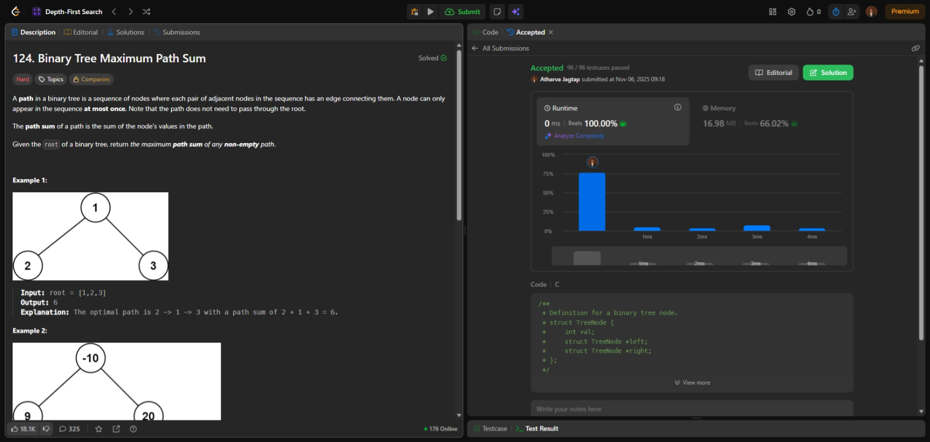

Topics Covered: Linked List / Queue
Level: Medium

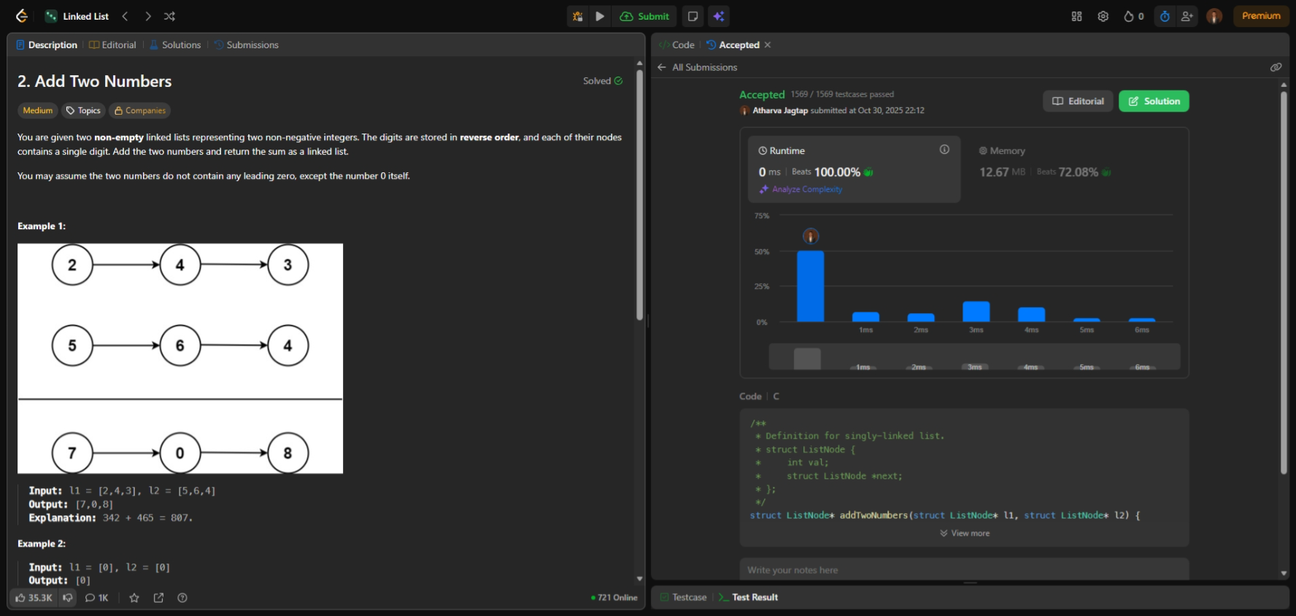

Topics Covered: Array / String
Level: Medium

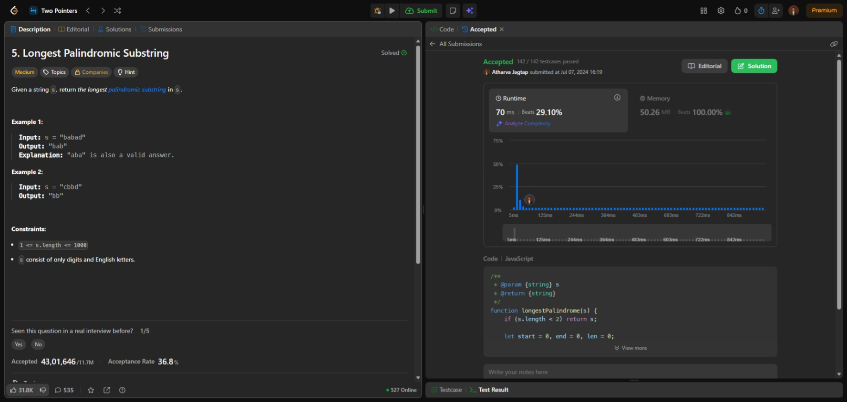

Topics Covered: Array / 2D Array / Stack
Level: Medium
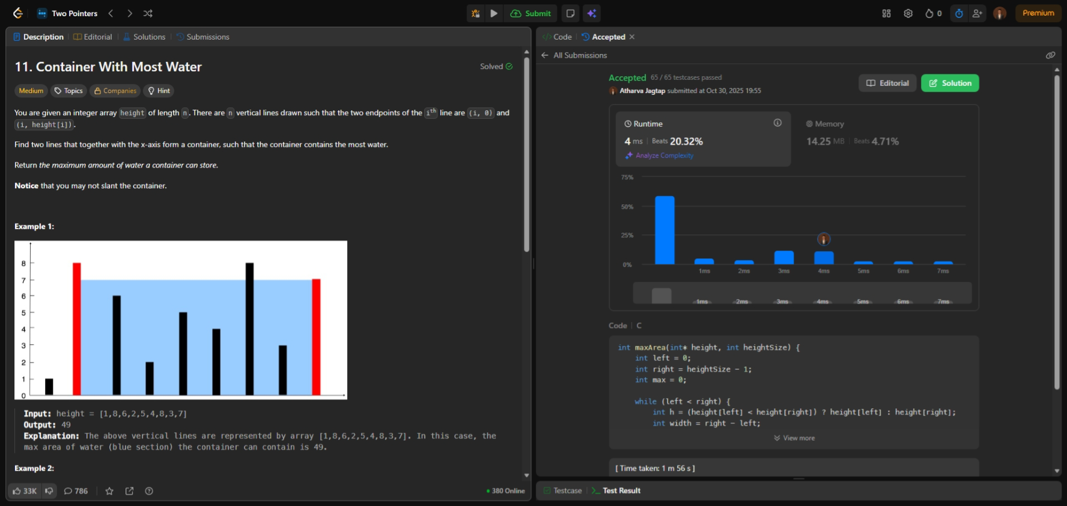

Topics Covered: Array / Stack
Level: Medium
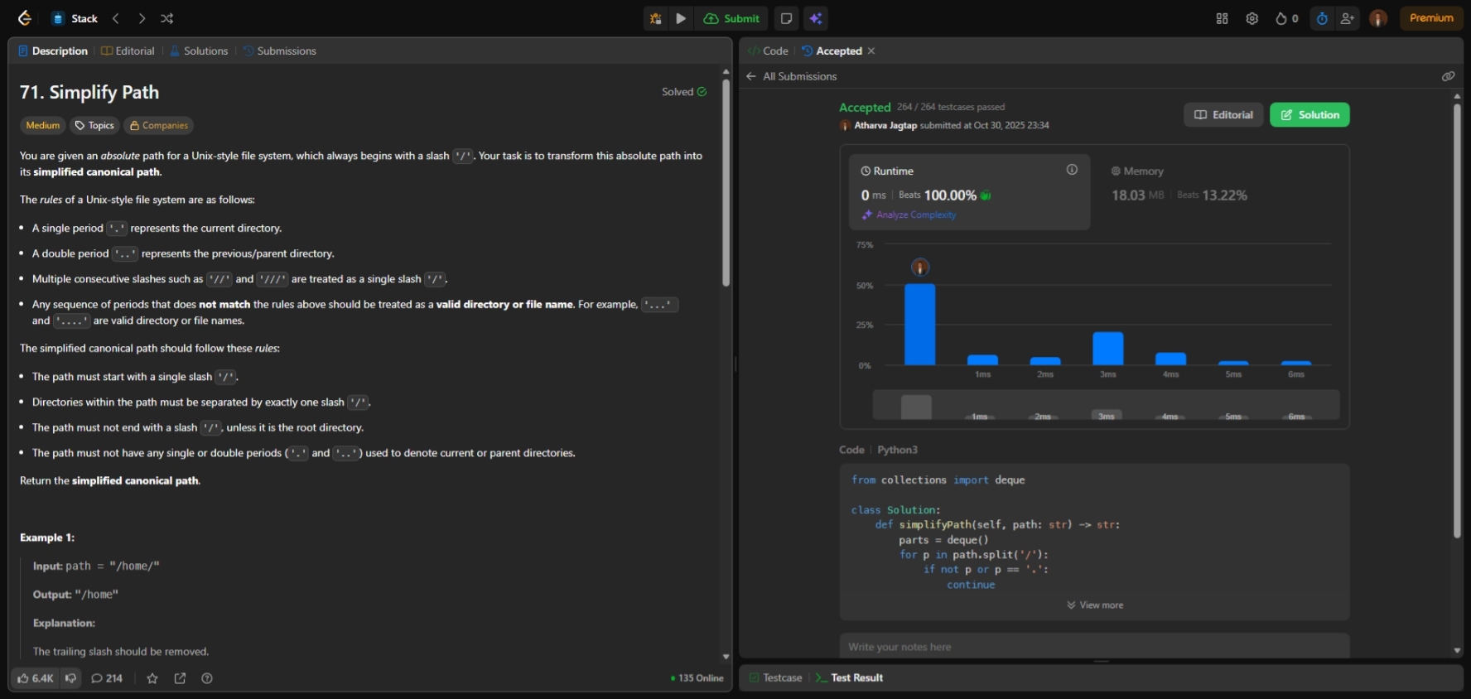

Topics Covered: Array / Stack / Backtracking
Level: Hard
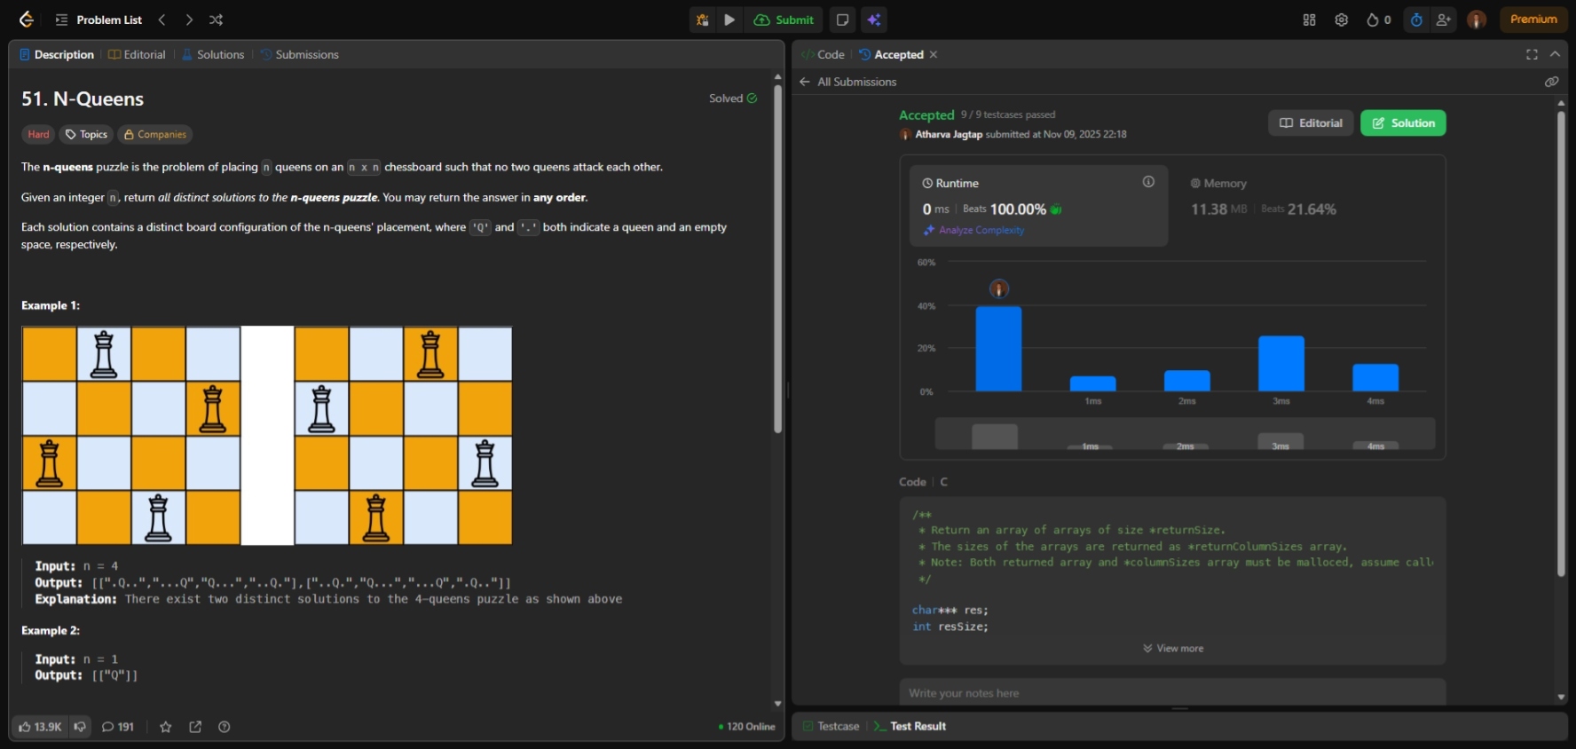

Topics Covered: Array / Binary Search
Level: Medium
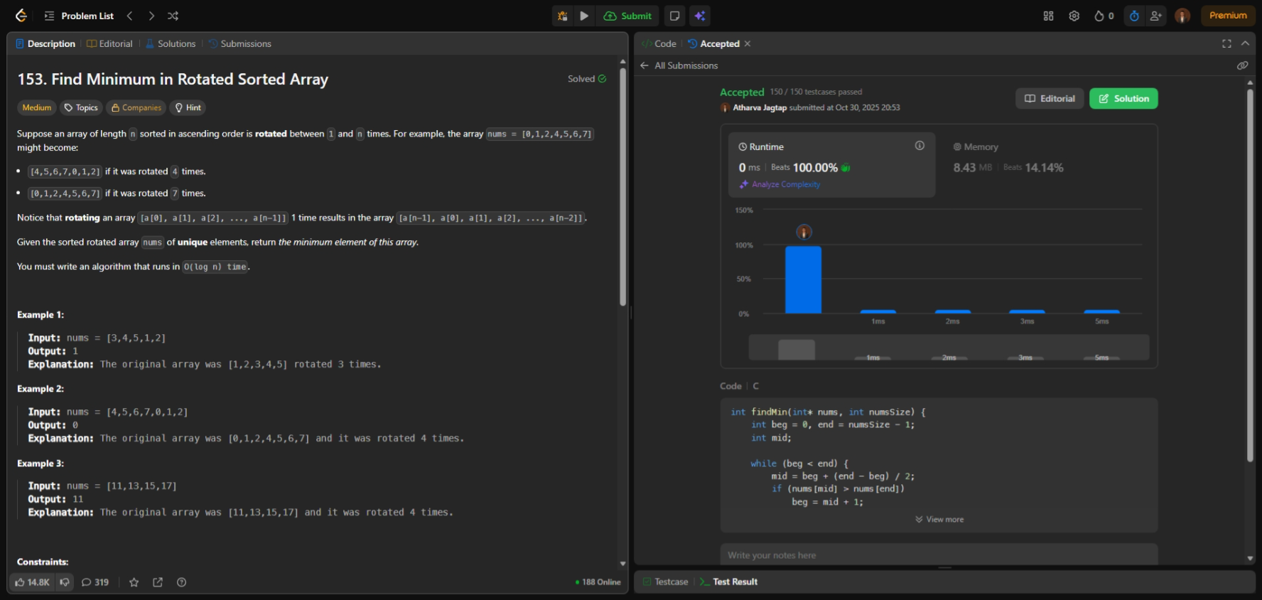

Topics Covered: Array / Binary Search
Level: Hard
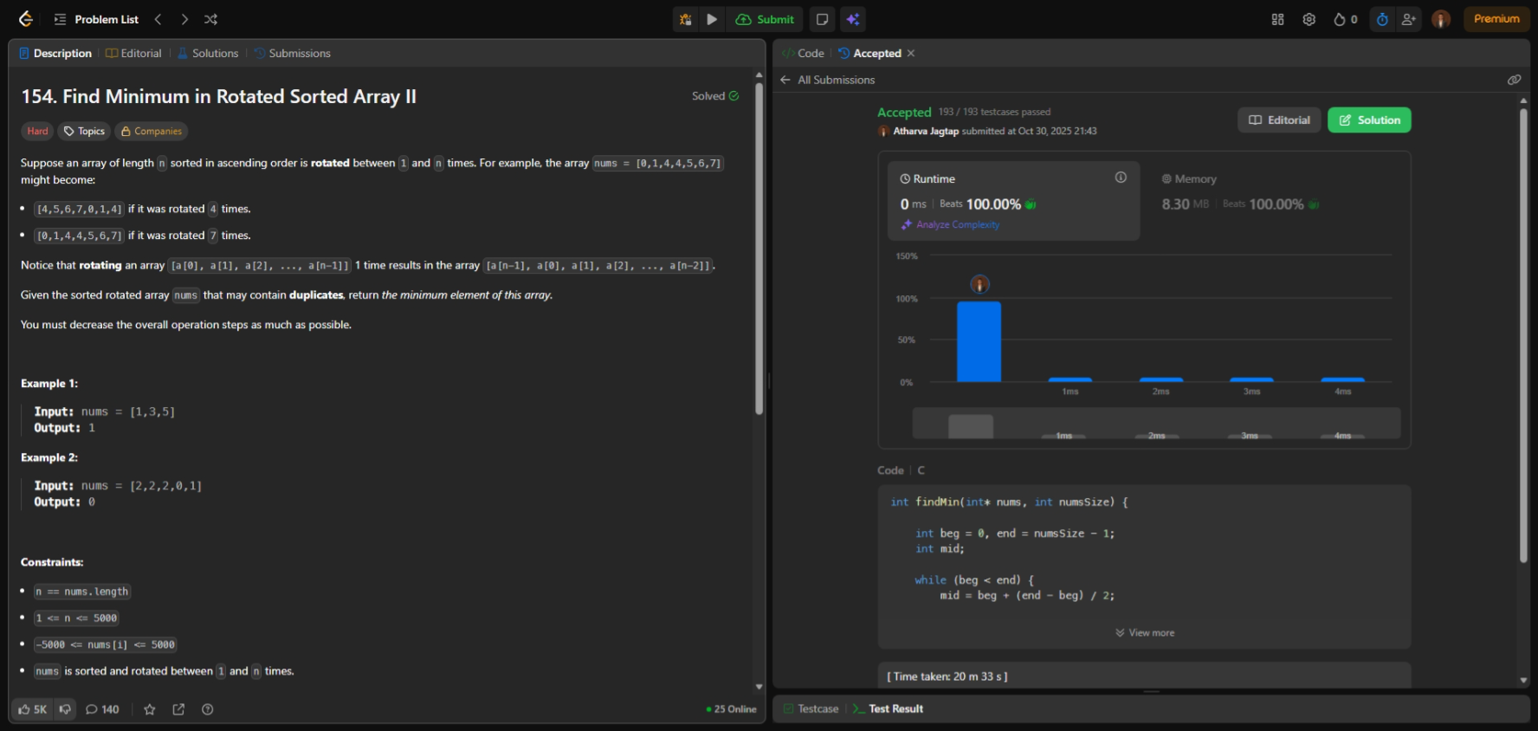

Topics Covered: Graph / Hash Table / DFS
Level: Medium
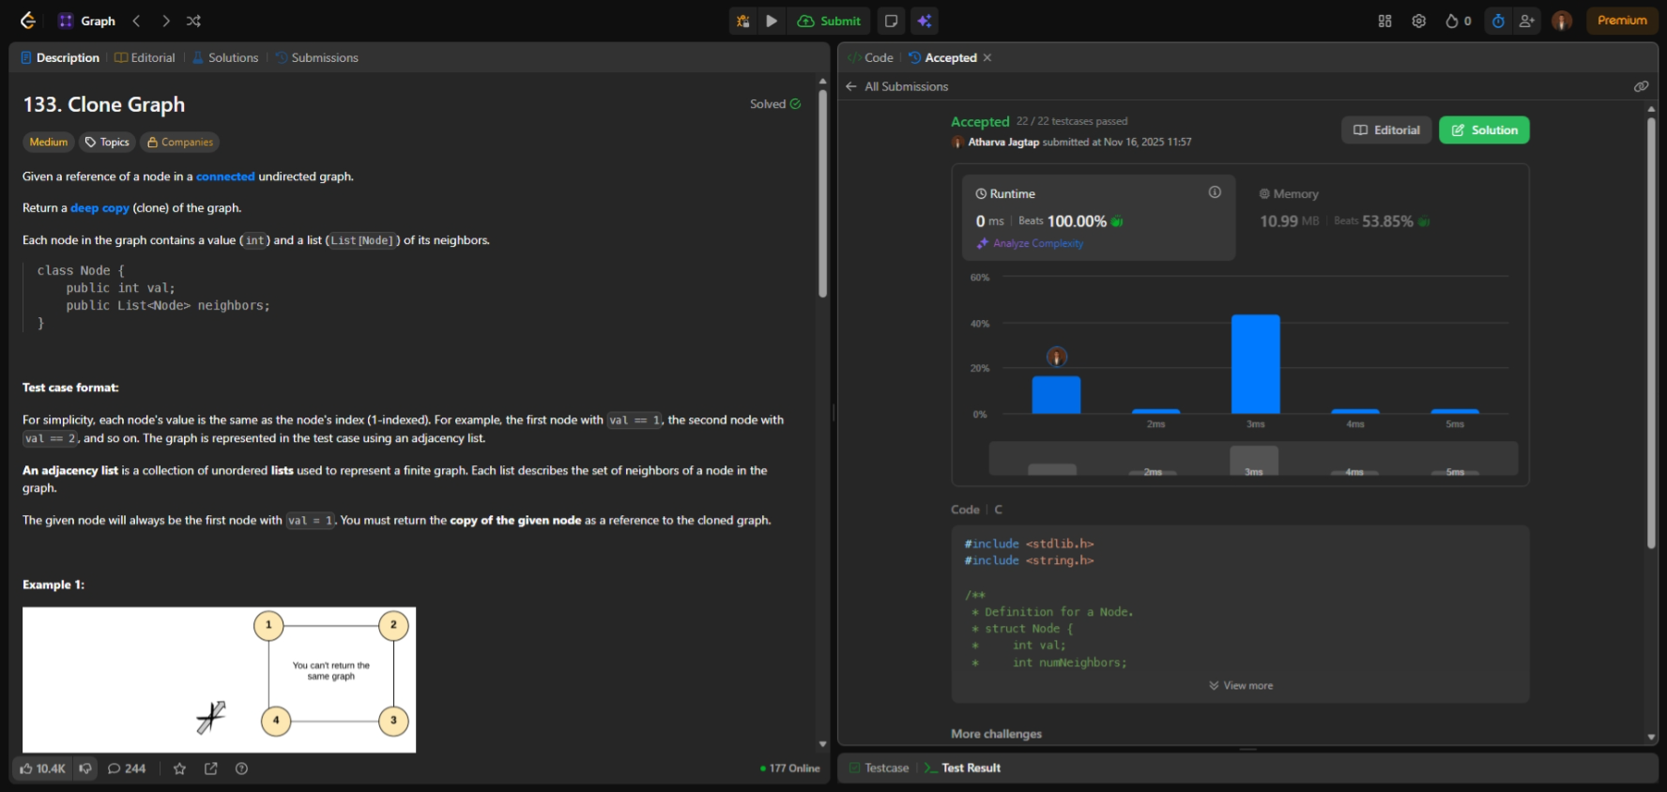

Topics Covered: Graph / BFS
Level: Medium
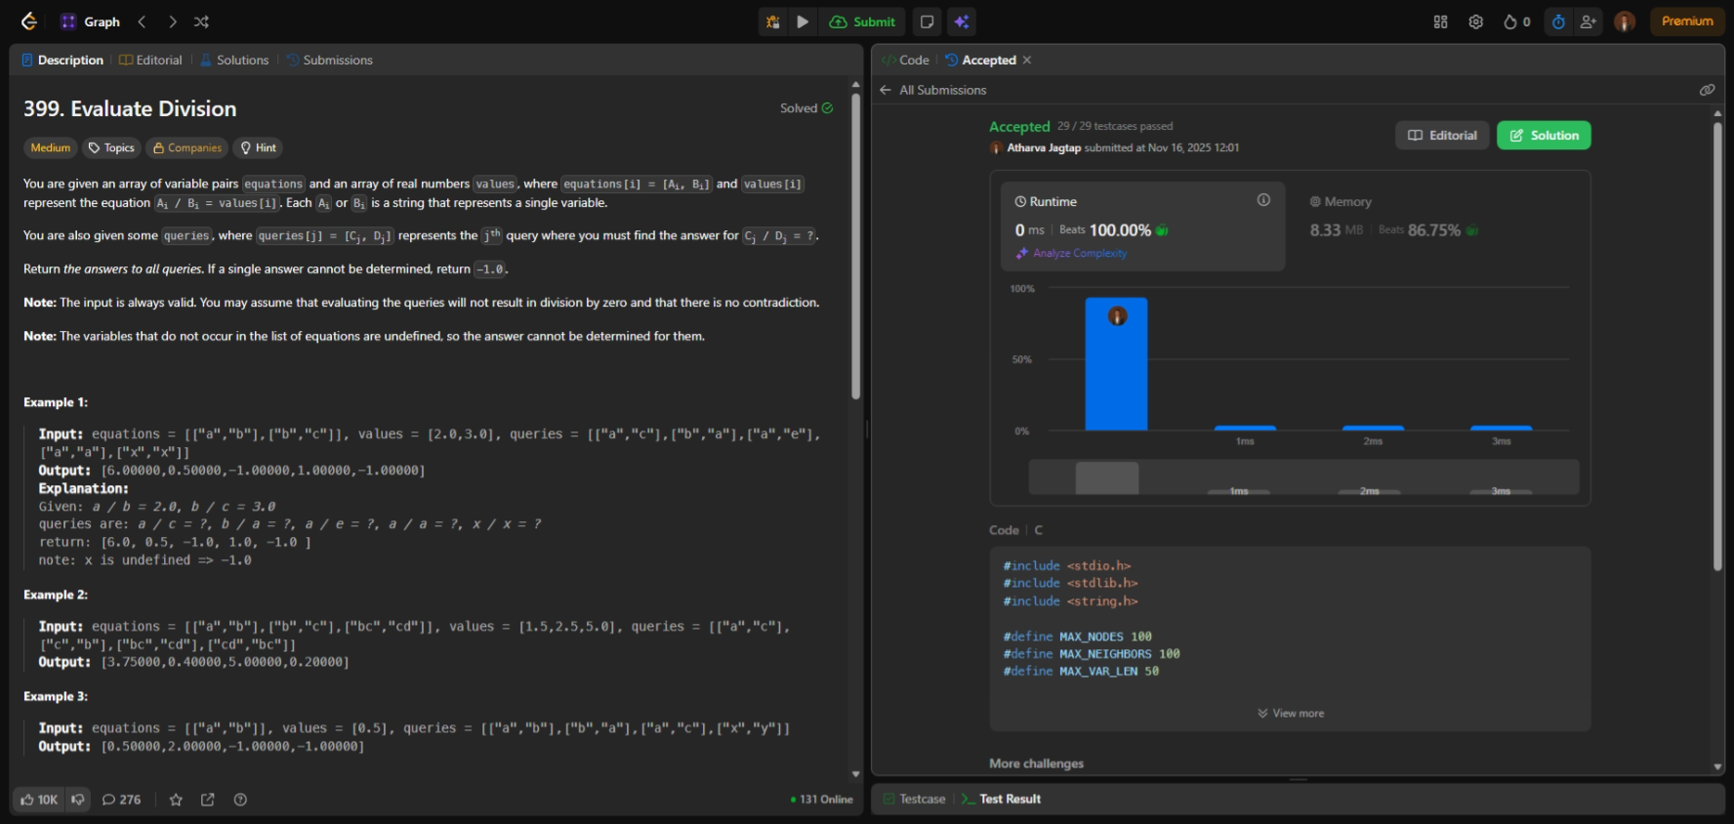

Topics Covered: Tree / Binary Tree / Dynamic Programming
Level: Medium
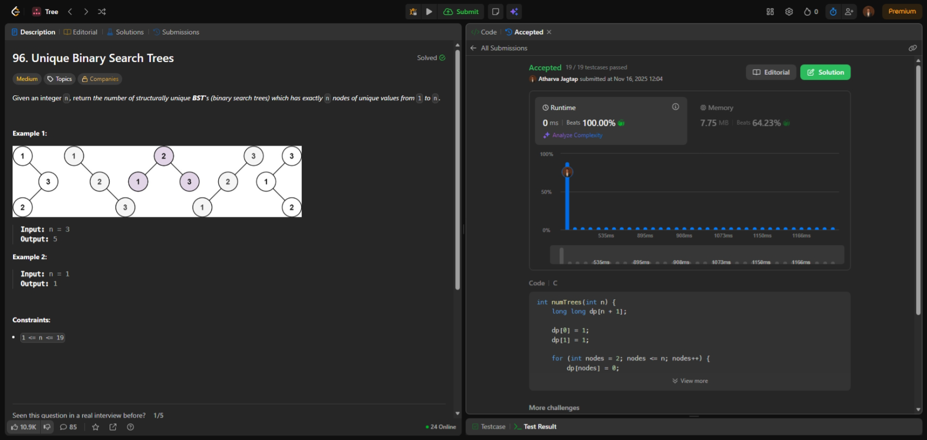

Topics Covered: Tree / Binary Tree / DFS
Level: Medium
